ASBO IMAGES USED IN THE BOOK
CHAPTER ONE: JEEBUS MADE ME DO IT
NUMBER 58 September 5, 2007

NUMBER 642 January 30, 2009

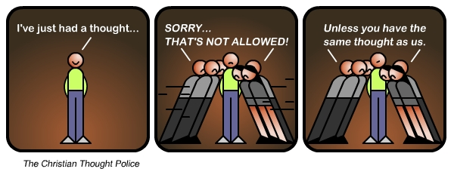

YOUR GOD IS TOO SICK: CHAPTER TWO
NUMBER 606 December 8, 2008
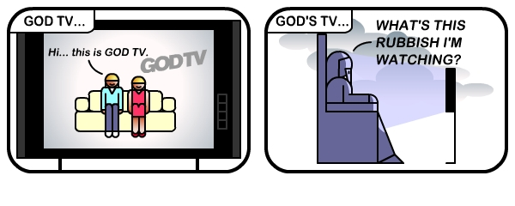
NUMBER 57 September 5, 2007
NUMBER 707 APRIL 24, 2009
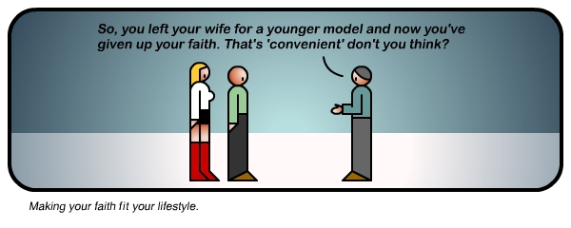
NUMBER 644 February 1, 2009
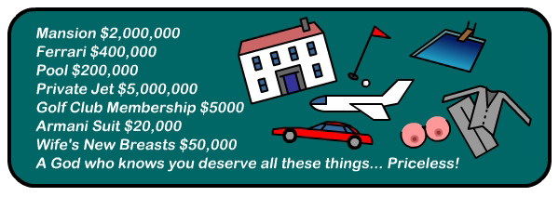
NUMBER 163 October 14, 2007
GETTING PLUGGED INTO GOD: CHAPTER THREE
NUMBER 692 April 2, 2009
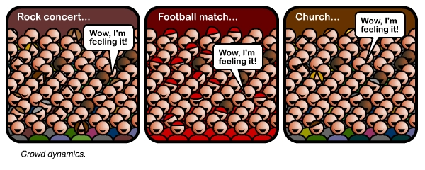

NUMBER 577 October 31, 2008
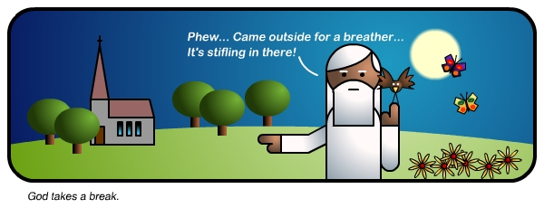
KULTCHA SMULTCHA: CHAPTER FOUR
NUMBER 562 October 3, 2008
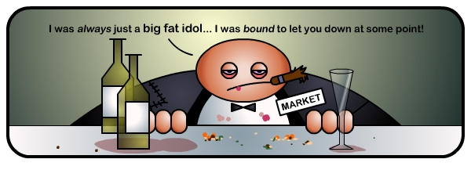NUMBER 208 October 30, 2007
THE CHURCH THAT JESUS BUILT: CHAPTER FIVE
NUMBER 402 March 7, 2008
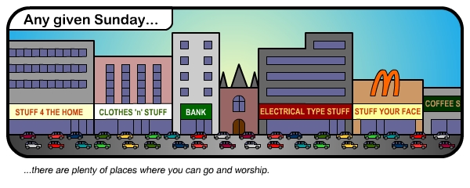
NUMBER 482 June 6, 2008
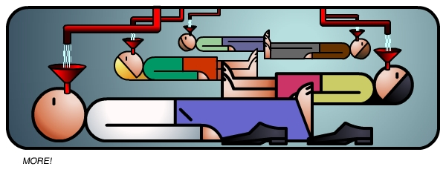
NUMBER 708 APRIL 27th, 2009
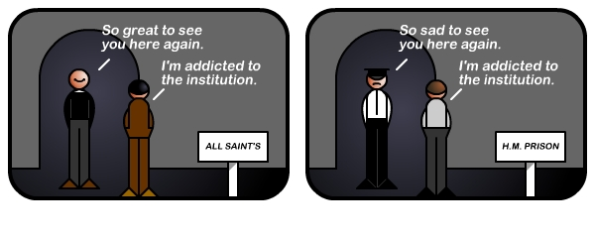
NUMBER 488 June 16, 2008
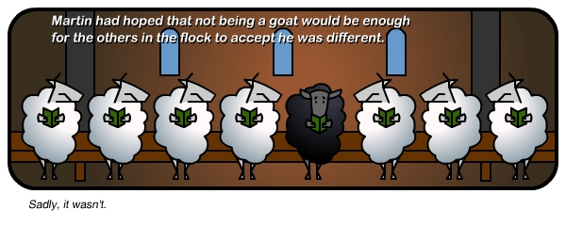
REFOCUSING THE FAMILY: CHAPTER SIX – NOTHING???
THE LYING MIRROR: CHAPTER SEVEN
NUMBER 674 March 12, 2009
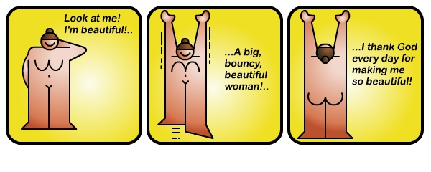
NUMBER 693 April 4, 2009 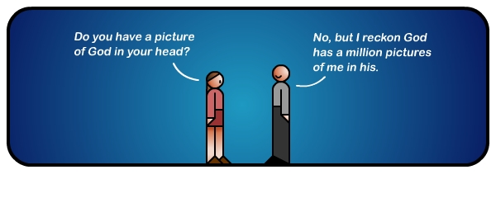
NUMBER 126 October 5, 2007

TOO SEXY FOT THE CHURCH: CHAPTER EIGHT
NUMBER 200 October 29, 2007

NUMBER 173 October 16, 2007
NUMBER 604 December 6, 2008
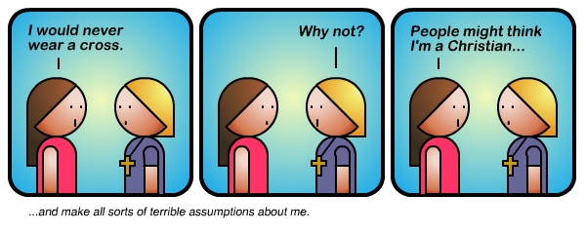

NUMBER 615 December 28, 2008
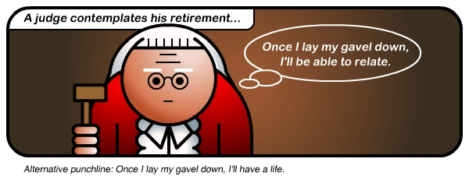
GOING OUT GOING DEEP: CHAPTER NINE
NUMBER 233 November 7, 2007

NUMBER 614 December 23, 2008
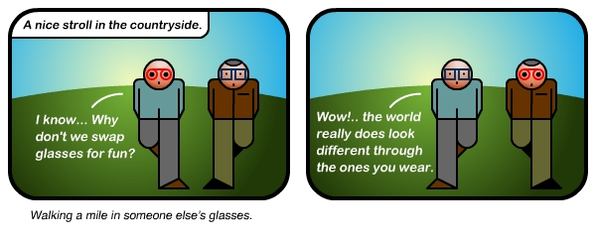

THESE HAVE YET TO BE INCLUDED BUT WE WOULD LIKE TO FIT THEM IN SOMEWHERE

NUMBER 361 January 26, 2008
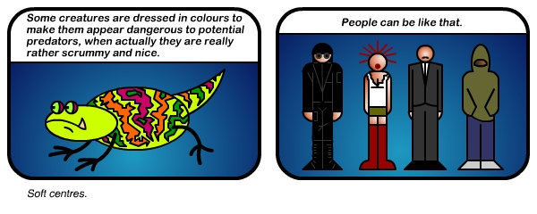
NUMBER 277 November 25, 2007
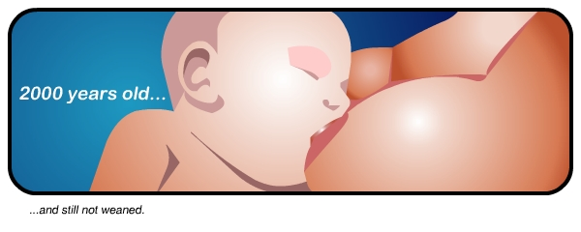

NUMBER 705 June 7, 2009

NUMBER 734 June 2, 2009

